s
Mo
Mobile App Dev
Assignment 1

Logan Kirby
27450556

Contents
Concept 2
Requirements 3
User Stories 3
Primary User Story 3
Secondary User Stories 3
Core Features 3
Prototyping 5
Strategy Plane 5
Scope Plane 5
Structure Plane 5
Skeleton Plane 6
Surface Plane 8
Colour Palette and Accessibility 9
Typography 9
Heuristic Evaluation 9
References 10

Concept
StepQuest is a mobile application designed to gamify daily walking through GPS-based territorial conquest. The app addresses the Neurodiversity and Mental Health theme by transforming physical activity into an engaging and goal-oriented experience that supports mental well-being and helps users establish a consistent exercise routine.
The application targets individuals who struggle with motivation for regular physical activity, particularly those with ADHD, depression, or general mental health challenges. By providing clear and achievable goals with immediate visual feedback, the app helps motivate people who often struggle with maintaining healthy habits.
The core functionality centres around exploring the user’s local environment, whether that be a university campus, city, or known attractions, where different geographical zones are occupied by unique boss characters. Users must physically walk to these territories to challenge bosses, with their daily step count translating into damage dealt. Each boss features distinct mechanics, requiring different walking patterns: some demanding consistency throughout the day, others require walking at specific times, and some need the user to walk at a specific speed. Defeating bosses claims territories on an interactive map, providing visual progress that reinforces achievement.
A mobile application is ideal for this concept because it fundamentally requires location-based gameplay through GPS tracking, continuous step monitoring via pedometer APIs, and background processing throughout the day. This experience is intrinsically tied to physical movement through real-world spaces; something impossible to accurately replicate on desktop or laptop devices. Requiring these features makes the app mobile-only rather than mobile-first.

Requirements

User Stories
To understand the specific needs of the target users, several user stories were developed to guide the design process:

Primary User Story
“As a university student struggling with maintaining regular exercise due to a lack of motivation, I want to turn my daily campus walk into a game where I can see my progress visually, so that I feel accomplished and motivated to walk more consistently”
This primary story reflects the core challenge identified in research on exercise adherence: lack of intrinsic motivation and abstract goal-setting (Deterding et al., 2011). Traditional step-counting applications often fail to maintain long-term engagement because numerical goals lack meaningful context and emotional connection (Munson and Consolvo, 2012).

Secondary User Stories
“As someone with ADHD, I want clear daily goals with immediate feedback, so I can overcome executive dysfunction and maintain a walking routine.”
This addresses the specific needs of a neurodivergent user. Research indicates that individuals with ADHD benefit significantly from gamified tasks with immediate rewards and visual progress indicators (Dovis et al., 2015).
“As a commuter who walks the same routes daily, I want to discover and interact with different locations during my travels, so that my necessary journeys feel more purposeful and engaging.”
“As someone interested in casual gaming, I want to collect and strategise with defeated bosses, so that my walking achievements translate into meaningful progression and strategic depth”

Core Features
Based on these user stories, the following core features were identified as essential for the minimum viable product:
- GPS territory system: display the user’s local area as an interactive map divided into territories, each occupied by boss characters. This provides the spatial context that makes walking purposeful rather than abstract
- Step-to-damage combat system: convert accumulated daily steps into damage dealt to challenged bosses. This mechanic transforms steps into game progression, creating what Whitson (2013) describes as “gamification of self-improvement”.
- Boss variety with unique mechanics: implement multiple boss types requiring different walking patterns. Examples include time-based bosses (only taking damage at certain times), velocity-based bosses (requiring consistent walking speed), and exploration-based bosses (requiring visits to multiple territories).
- Territory claiming visualisation: provide clear visual representation of conquered territories on the map.
- Boss collection system: store defeated bosses as collectable cards with passive abilities that can be equipped for strategic advantage in future battles.
- Real-time progress tracking: display current battle status, step count, and territory control throughout the day, providing the immediate feedback crucial for users with ADHD.

Prototyping
The design of StepQuest followed the Five Planes of User Experience framework developed by Garrett (2002), progressing systematically from an abstract idea into a concrete interface design. This methodology ensures that each design decision connects logically to user needs identified in the requirement phase.

Strategy Plane
The strategy plane addresses the fundamental question: why are we creating this product, and what do users need from it?
Research into gamification of physical activity reveals that traditional fitness applications often employ extrinsic motivation through social comparison, which has limited long-term effectiveness (Hamari and Koivisto, 2015). StepQuest instead focuses on intrinsic motivation through spatial exploration and strategic gameplay.
For users with ADHD or depression, the primary barrier to physical activity is often referred to as the activation energy: the mental effort required to begin a task (Steel, 2007). This app addresses this by providing multiple entry points with varying commitment levels. For example, challenging a new boss represents a full-day commitment, while patrolling an owned territory requires only a brief walk. This flexibility accommodates varying energy levels and executive function capacity.
The spatial nature of the game addresses research findings that location-based games increase environmental engagement and encourage exploration of local areas. By overlaying gameplay onto familiar environments, the app transforms routine spaces into areas of strategic interest.

Scope Plane
The scope plane defines available features and functions. Functional requirements include viewing the local area as an interactive GPS-tracked map displaying territories occupied by boss characters. Users can view territory details, challenge bosses by setting a step goal, track progress using a pedometer throughout the day, and claim defeated territories. Collection mechanics allow users to store defeated bosses as cards, inspect their passive abilities, and equip teams of three for bonuses. Adjacent player-owned territories can form kingdoms, which provide more strategic benefits, including a buff which slows down the decay rate of a territory.
Content requirements include many unique boss characters with distinct visual designs and mechanics, territory data with geographical boundaries and control status, and visual assets including boss illustrations and territory overlays. These integrate with real-world map data provided through APIs.

Structure Plane
The structure plane defines how users navigate through the application and how information is organised. The app employs a hub-and-spoke navigation model with the Map View serving as the central hub. This structure reflects the spatial nature of the game, where the map is simultaneously the game board and primary navigation interface.
From the Main Page, users can navigate to three primary sections: Settings for app configuration, Profile for viewing statistics and achievements, or interact directly with territories on the map. When users tap a territory, they navigate to the Individual Territory screen, which branches into two distinct paths depending on territory ownership. Enemy or neutral territories lead to the Battle screen where users set goals and engage in challenges, with successful battles culminating in a Victory screen displaying rewards. Owned territories instead navigate to the Your Territory screen where users can patrol to prevent decay and view kingdom formations. The Collection screen is accessible from the Individual Territory screen, allowing users to view their defeated bosses and modify equipped teams. This navigation structure implements progressive disclosure: the Main Page shows territorial overview at a glance, Individual Territory screens reveal detailed boss information and mechanics, and subsequent screens provide specialized interactions based on context. This approach prevents cognitive overload while ensuring users can access the specific functionality they need efficiently.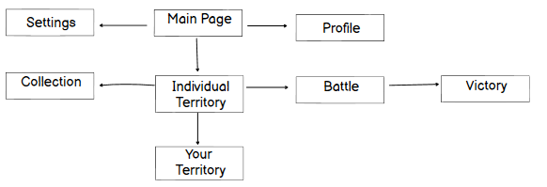

Skeleton Plane
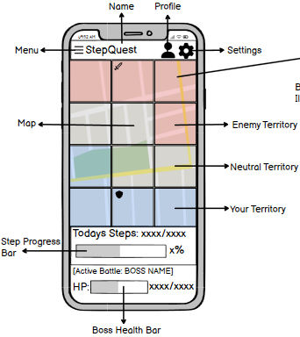
The skeleton plane translates the structure plane into concrete layouts. The Map View employs a full-screen display with colour-coded territory overlays (red for enemy, grey for neutral and blue for owned).
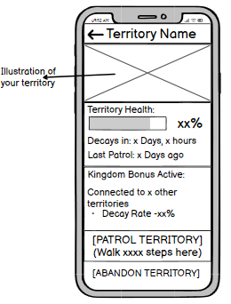
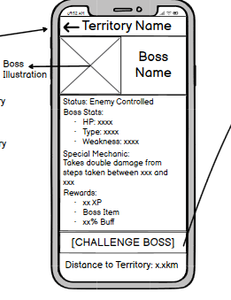
On the Territory Details screen, you can see the status and boss information, as well as the distance you are away from the territory. It also showcases the rewards and provides the user with the “Challenge Boss” button.

The Battle Setup screen focuses on two main decisions: the step goal, with a suggested value based on your average steps, and a team selection showing three equipped boss cards and their buffs.
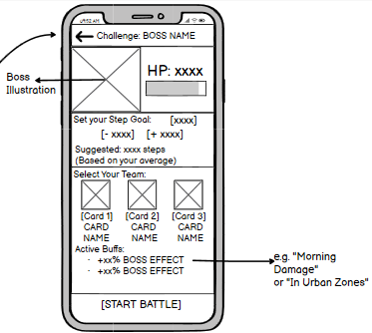
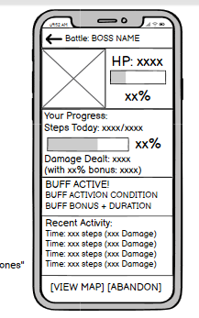
The Active Battle screen showcases real-time information with the boss's health bar, the user’s progress bar, and recent activity logs.

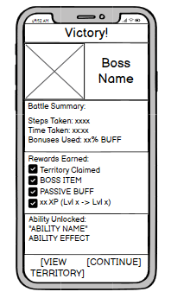
The Victory screen shows the user a battle summary and their clearly marked rewards. It also can take the user back to the Map View screen.
The Profile screen uses a sectioned layout for statistics, achievements, and a weekly activity chart. Meanwhile, the Boss collection screen employs a scrollable card grid with the current team displayed at the bottom.
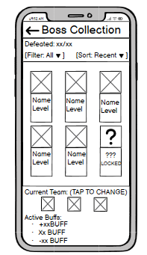
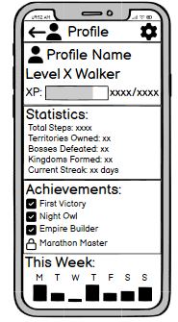

Information follows the visual hierarchy principles (Lidwell et al., 2003) where primary information, like steps and battle status, are always visible; secondary details are one tap away and historical data, like statistics, require deeper navigation.

Surface Plane
The surface plane defines the visual design. The aesthetics balances playful gamification with mental health sensitivity, as aggressive design can increase user anxiety.

Colour Palette and Accessibility
The colour palette uses a calming blue for owned territories, often associated with trust and achievement, a warm red for enemy territories indicating challenge without aggression. Neutral territories use a soft grey, presenting unexplored areas as approachable opportunities rather than intimidating challenges.
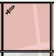
Critically, colour is never the sole method of conveying information. To help with colourblind users, the territories also use iconography. Owned territory display a shield icon symbolizing protection, while enemy territory showcases a sword indicating challenge. This approach ensures that all users can distinguish territory states regardless of their colour perception abilities, following the universal design principles

Typography
The design employs a retro arcade aesthetic to reinforce the gaming experience. The Game Paused font created by Dharmas Studio (https://www.fontspace.com/game-paused-font-f102167) was selected for its pixel-art inspired letterforms that immediately communicate playfulness and gaming heritage. This font also helps differentiate this app from a generic fitness application users may have previously abandoned.

Heuristic Evaluation
A heuristic evaluation using Nielsen’s (1994) 10 Usability Heuristics identified strengths and weaknesses. The app excels in visibility of the system status through persistent step counters and real-time battle updates. The match between system and real world is achieved through recognisable map data with familiar locations names and thematically appropriate boss naming.
User control and freedom allow penalty-free battle abandonment, though evaluated revealed missing confirmation dialogs which was corrected by adding a two-step confirmation to prevent accidental progress loss. The app has consistent navigation and interaction patterns; however, the absence of a persistent bottom navigation differs from common mobile applications. Users must return to the Map View to access other sections, which could hinder quick navigation during active use. This trade-off prioritises screen space for map visibility but map impact user efficiency.
Error prevention includes a distance indicator which prevent the user from challenging a territory that they are not in. Also, the step goal suggestion based on user history prevents discouragement from unrealistic targets. Displaying the boss’s mechanics on a detail screen, as well as displaying the buffs given to the player by their team, eliminate the need to remember as much detail as possible.
Initial prototypes violated the aesthetic and minimalist design by including excessive statistics on the Battle Setup screen. Heuristic evaluation identified this issue and resolved it with the inclusion of collapsable sections that hide advanced information. Error messages also include easy to read comments like “Unable to determine your location accurately”, rather than technical codes, which help the user recognise and fix the error.
The evaluation revealed the app generally adheres to the usability principles, with key improvements made where necessary, ensuring the final design meets the user’s needs while following the best usability practices.

References
10 Usability Heuristics for User Interface Design [WWW Document], n.d. . Nielsen Norman Group. URL https://www.nngroup.com/articles/ten-usability-heuristics/ (accessed 11.25.25).
Deterding, S., Dixon, D., Khaled, R., Nacke, L., 2011. From game design elements to gamefulness: defining “gamification,” in: Proceedings of the 15th International Academic MindTrek Conference: Envisioning Future Media Environments, MindTrek ’11. Association for Computing Machinery, New York, NY, USA, pp. 9–15. https://doi.org/10.1145/2181037.2181040
Dovis, S., Oord, S.V. der, Wiers, R.W., Prins, P.J.M., 2015. Improving Executive Functioning in Children with ADHD: Training Multiple Executive Functions within the Context of a Computer Game. A Randomized Double-Blind Placebo Controlled Trial. PLOS ONE 10, e0121651. https://doi.org/10.1371/journal.pone.0121651
Garrett, J.J., 2002. The elements of user experience: user-centered design for the Web, 1st ed. ed. New Riders, Indianapolis, Ind.
Hamari, J., Koivisto, J., 2015. Why do people use gamification services? International Journal of Information Management 35, 419–431. https://doi.org/10.1016/j.ijinfomgt.2015.04.006
Lidwell, W., Holden, K., Butler, J., 2003. Universal principles of design: 100 ways to enhance usability, influence perception, increase appeal, make better design decisions, and teach through design. Rockport Publ, Beverly, Mass.
Munson, S., Consolvo, S., 2012. Exploring Goal-setting, Rewards, Self-monitoring, and Sharing to Motivate Physical Activity. Presented at the 6th International Conference on Pervasive Computing Technologies for Healthcare.
Steel, P., 2007. The nature of procrastination: A meta-analytic and theoretical review of quintessential self-regulatory failure. Psychological Bulletin 133, 65–94. https://doi.org/10.1037/0033-2909.133.1.65

